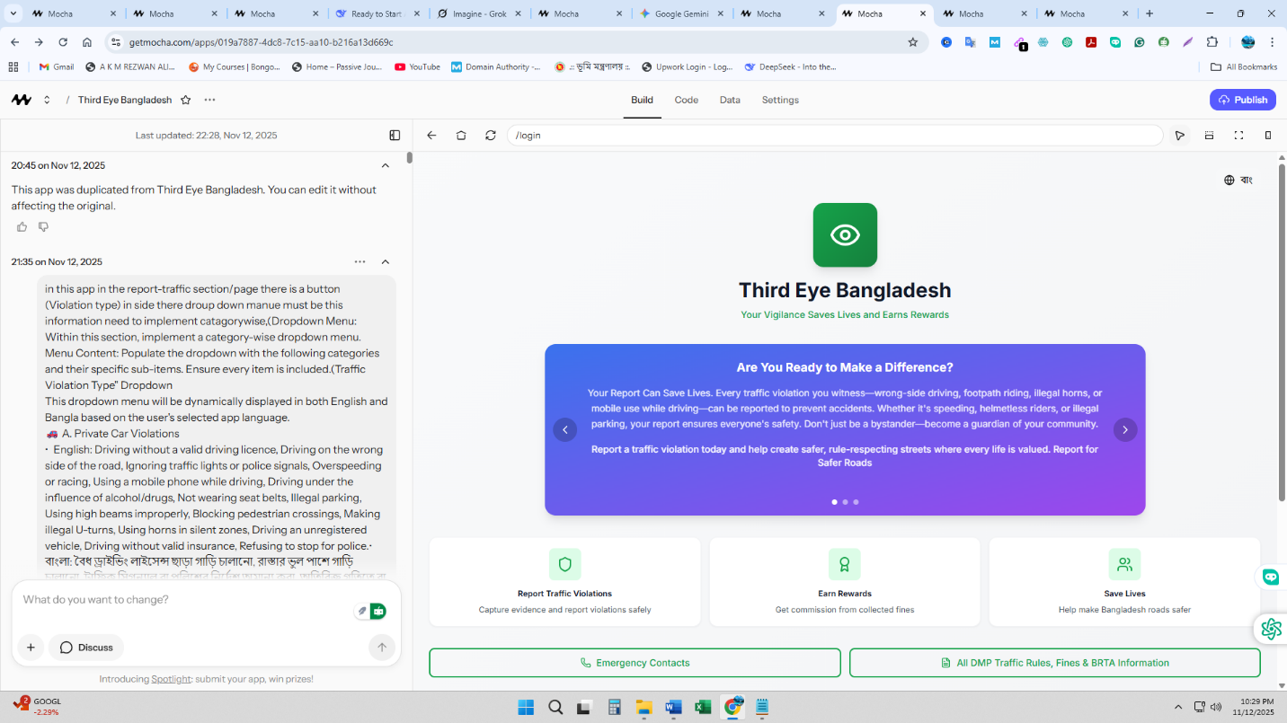

The demo account information is documented in the DEMO_ACCOUNTS.md file. Here are the login credentials:
Citizen Account:
- Phone: 01712345678
- Email: demo@thirdeye.gov.bd
- Password: demo123
Officer Account:
- Phone: 01812345678
- Email: officer@dmp.gov.bd
- Password: demo123
These demo accounts come pre-loaded with sample reports in various states (pending, approved, rejected) so you can test the complete workflow from citizen reporting to officer review. Check the DEMO_ACCOUNTS.md and TESTING_GUIDE.md files for detailed testing instructions and features to verify.

